**SRM Institute of Science & Technology, Tiruchirappalli**

**Faculty of Engineering and Technology**

**Department of Electronics and Communication Engineering**

**Lesson Plan**

**Academic Year :** 2023 - 24  **Semester :** IV

**Total Hours :** L - 45 Hrs

|  |  |  |  |  |  |  |  |  |  |  |
| --- | --- | --- | --- | --- | --- | --- | --- | --- | --- | --- |
| **Course Code** | 21ECE203J | **Course Name** | Smart Sensors and Devices for Agriculture | **Course Category** | PE | Professional Elective | L | T | P | C |
| 2 | 0 | 2 | 3 |

| **Session** | **Topic** | **Mode of Teaching** | **Ref. books** |
| --- | --- | --- | --- |
| Unit-1 : **Sensor fundamentals and characteristics** | | | |
|  | Introduction to sensors, Types of sensors | PPT | R6, W1, W2 |
|  | Performance characteristics, and applications | PPT | R6, W1, W2 |
|  | Location sensors, Optical sensors | PPT | R6, W1, W2 |
|  | Electrochemical sensors, Mechanical sensors | PPT | R6, W1, W2 |
|  | Dielectric soil moisture sensors, Airflow sensors | PPT | R6, W1, W2 |
|  | pH sensors, Accelerometer sensors | PPT | R6, W1, W2 |
|  | Nano sensors, Nano biosensors, Application of sensors | PPT | R6, W1, W2 |
|  | *Practice:* Application of sensors in agriculture -Soil moisture sensors for monitoring plants, Electronic soil sensors to conserve water. | | |
|  |
| Unit-2 : **Remote sensing sensors for precision agriculture** | | | |
|  | Classification of remote sensors | PPT | R2 |
|  | Selection of sensor parameters | PPT | R2 |
|  | Spatial resolution, Spectral resolution | PPT | R2 |
|  | Radiometric resolution, Temporal resolution | PPT | R2 |
|  | Optical infrared sensors | PPT | R2 |
|  | GPS sensors, Agricultural temperature sensors | PPT | R2 |
|  | LiDAR | PPT | R2 |
|  | *Practice:* Application of GPS sensors, Agricultural temperature sensors for precision agriculture | | |
|  |
| Unit-3: **Nanosensors in agriculture** | | | |
|  | Nanoparticles, Nanoparticles based nanosensors for agriculture | PPT | R3 |
|  | Nanosensors in pesticide detection in soil | PPT | R3 |
|  |
|  | Nanobiosensors – basic principle and characteristics | PPT | R3 |
|  |
|  | Nanobiosensors for microbial detection in soil | PPT | R3 |
|  |
|  | *Practice :* Application of sensors for detection of humidity of soil, pesticide residue, nutrient requirement and crop pest identification | | |
|  |
| Unit-4 : **IoT-based devices in agriculture** | | | |
|  | Agricultural Informatics -technological Components, IoT Basics | PPT | R1(43) |
|  | Characteristics of IoT and its Applications in Agriculture | PPT | R1 |
|  | IoT Requirements, Issues & Challenges | PPT | R1(45) |
|  | IoT Architectures towards urban greening | PPT | R1(171) |
|  | G-IoT, G-IoT Applications, G-IoT challenges, and opportunities | PPT | R1 |
|  | Need for a smart e-monitoring system for agriculture | PPT | R1(183) |
|  | Case study on IoT based monitoring systems, Research Challenges | PPT | R4,R1 |
|  | *Practice:* IoT devices for monitoring applications and precision farming | | |
|  |
| Unit-5: **AI, Edge, and IoT frameworks for agriculture** | | | |
|  | A fog computing-based IoT framework for prediction of crop disease using big data analytics | PPT | R1(17,287) |
|  |
|  | Renewable energy and AI-powered IoT | PPT | R1(205) |
|  |
|  | Architecture and system design | PPT | R1(212) |
|  | User operability | PPT | R1(220) |
|  | Applications, Advantages, and Limitations | PPT | R1(221) |
|  | *Practice* : Smart Precision farming application using AI, Edge and IoT. | | |
|  |

**Reference Books:**

1. Ajith Abraham, Sujata Dash, Joel J.P.C. Rodrigues, Biswaranjan Acharya, Subhendu Kumar Pani “AI, Edge and IoT-based Smart Agriculture”, Elsevier Science,2021
2. D.D. Sahu , “Remote Sensing: Techniques in Agriculture” , Agrobios (India) January 2008.
3. Adil Denizli, Tuan Anh Nguyen, Susai Rajendran, Ghulam Yasin, Ashok Kumar, “Nanosensors for Agriculture, Elsevier Science,2021
4. Annamaria Castrignano, Gabriele Buttafuoco, Raj Khosla, Abdul Mouazen, Dimitrios Moshou, Olivier Naud, “Agricultural Internet of Things and Decision Support for Precision Smart Farming”, Elsevier Science, 2020
5. Rajesh Singh, “Internet of Things (IoT) Enabled Automation in Agriculture: Enabled Automation in Agriculture” New India Publishing Agency- Nipa , 2018
6. Patranabis, D., “Sensors and Transducers”, 2nd Edition, Prentice Hall India Pvt. Ltd, 2010.

**Web Materials**

1. <https://www.simoniot.com/sensors-in-agriculture/>
2. https://www.tractorjunction.com/blog/types-of-smart-sensors-in-agriculture-for-farming-in-india/

**Assessment Procedure:**

|  |  |  |  |
| --- | --- | --- | --- |
| **CLO** | **Continuous Learning Assessment** | **Internal mark weightage (50)** | |
| **Theory (50)** | **Practice (10)** |
| CLO1 | CLA1 | 10 | Mini project 10 |
| CLO2 |
| CLO3 | CLA2 | 20 |
| CLO4 |
| CLO5 | CLA3 | 20 |

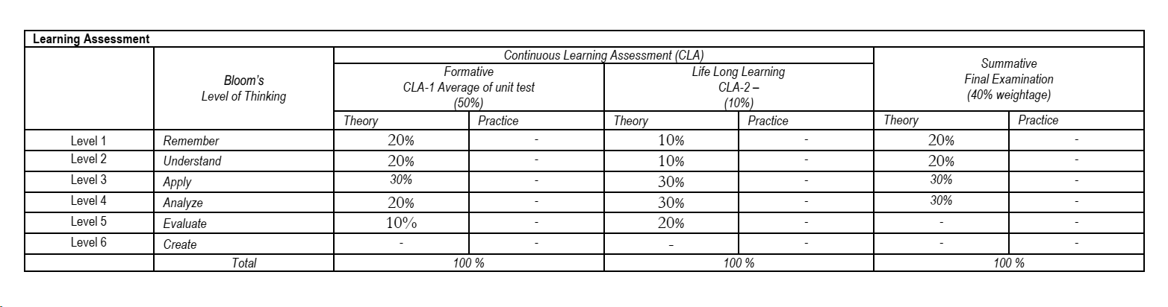

**Course Instructor HoD**